**Assignment No.: 10**

**Problem Statement**: Deploy a project from GitHub to EC2 by creating a new security group and user data. Procedure:

1. Access your AWS console and search for EC2, then proceed to click on the first option. Now click on "Security Groups". Now click on “Create security Group”.

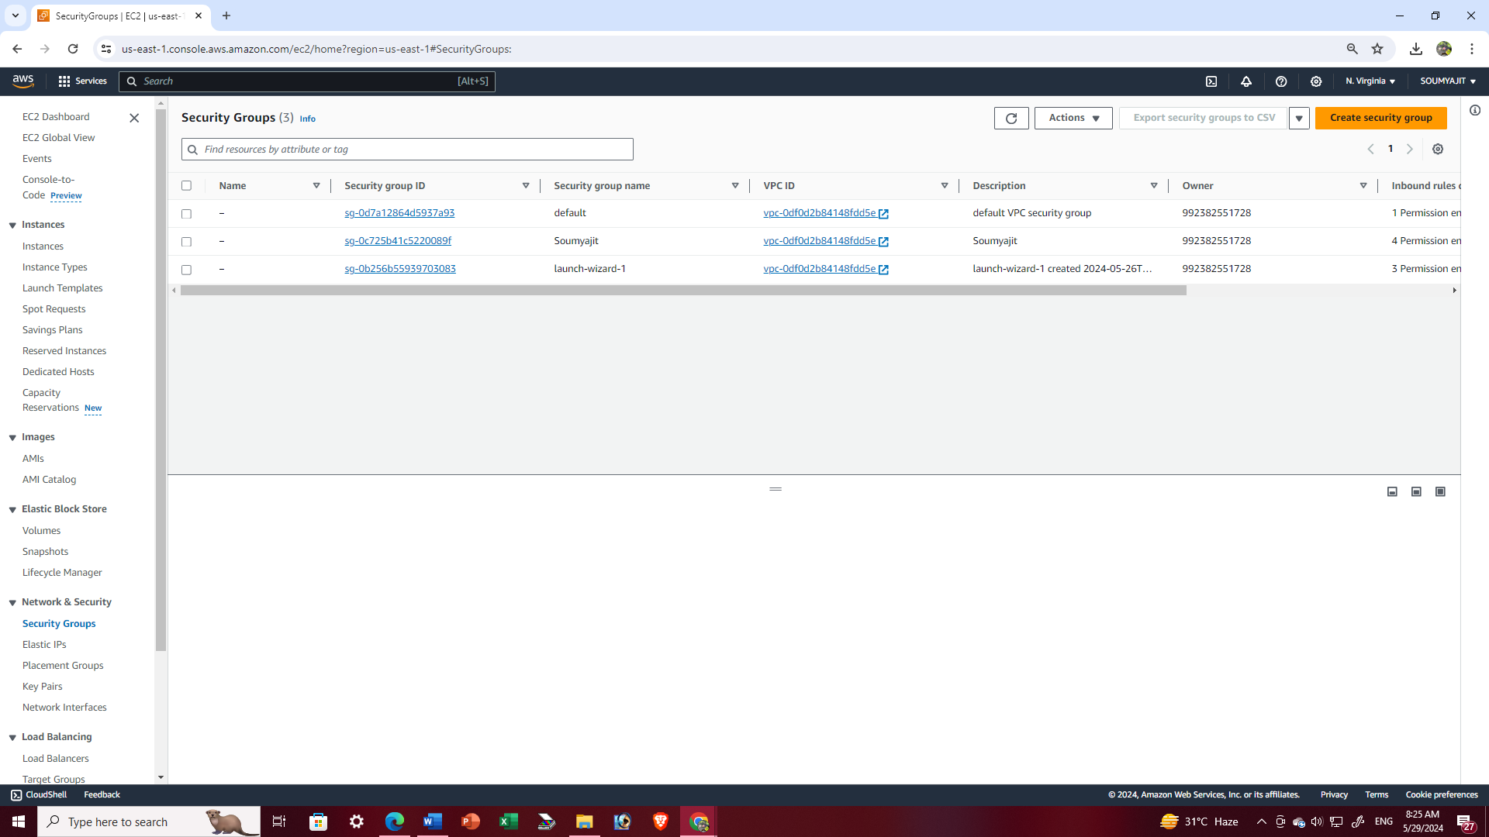

1. Fill up the name and description of the security group. Now, scroll down to Inbound Rules and click on “Add rule”. Set the port number as 4000 and select first option in CIDR blocks i.e. “0.0.0.0/0”. Click on “Add rule” again and set type as “SSH” and select the first option in CIDR blocks. Repeat this two more times and add rules of type “HTTP” and “HTTPS”.

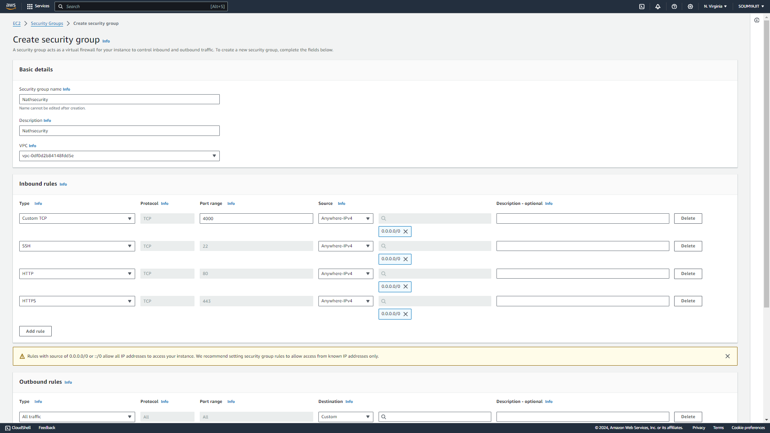

1. Click on “Create security group”.

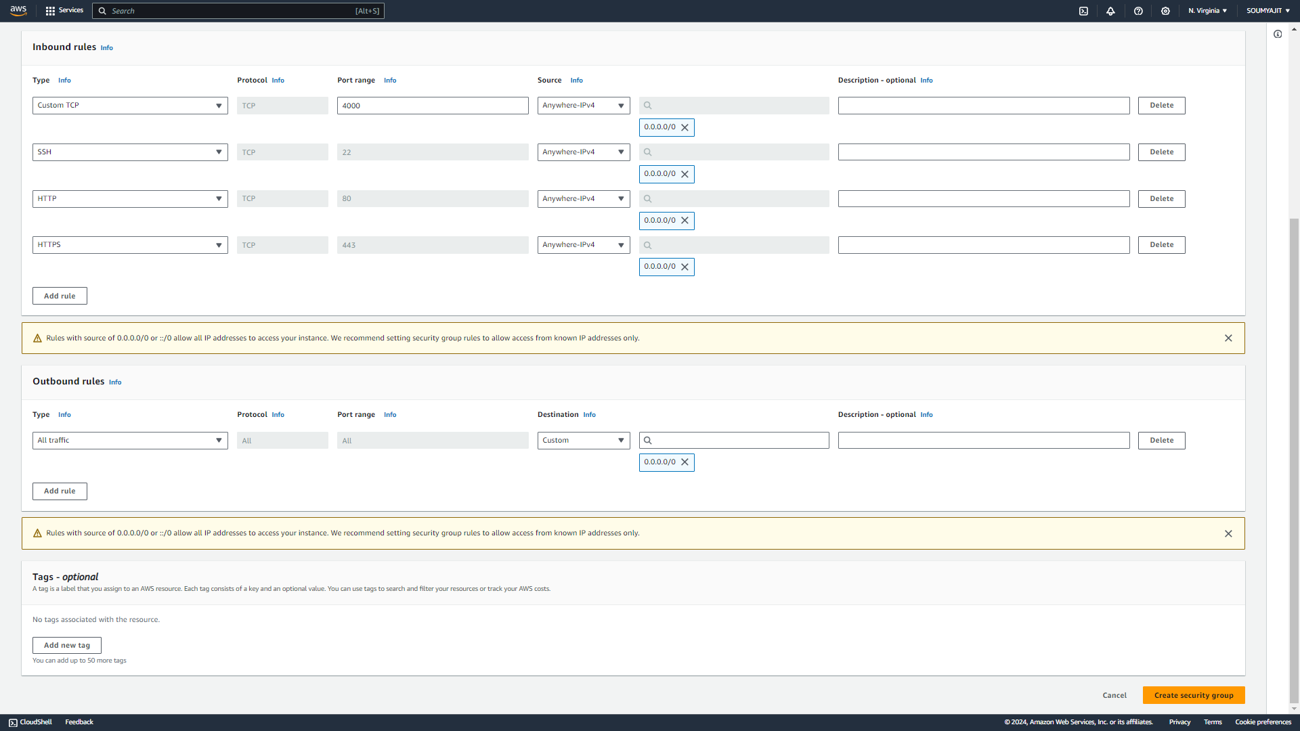

1. Security group is created successfully

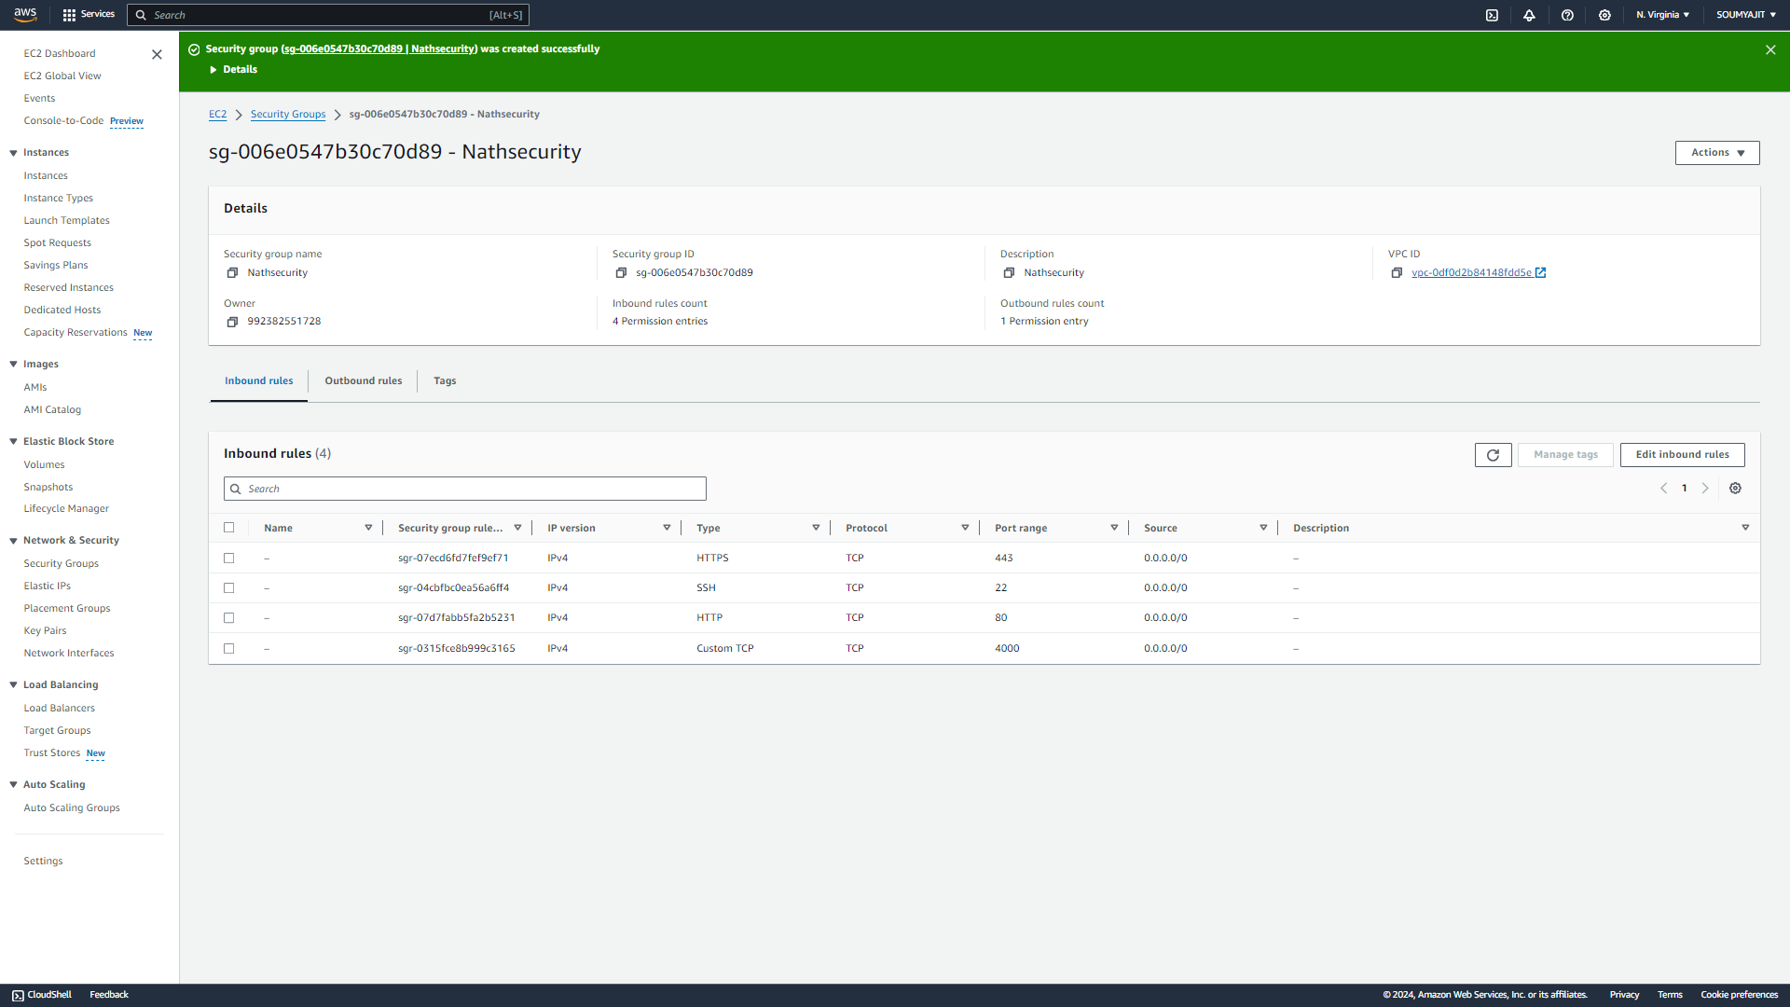

1. Now, go to EC2 dashboard and click on “Launch instance”.

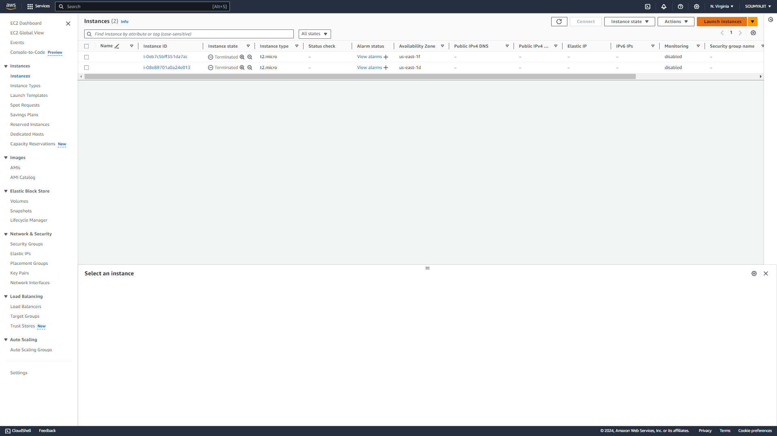

1. Fill up the instance name and select Ubuntu as the AMI.

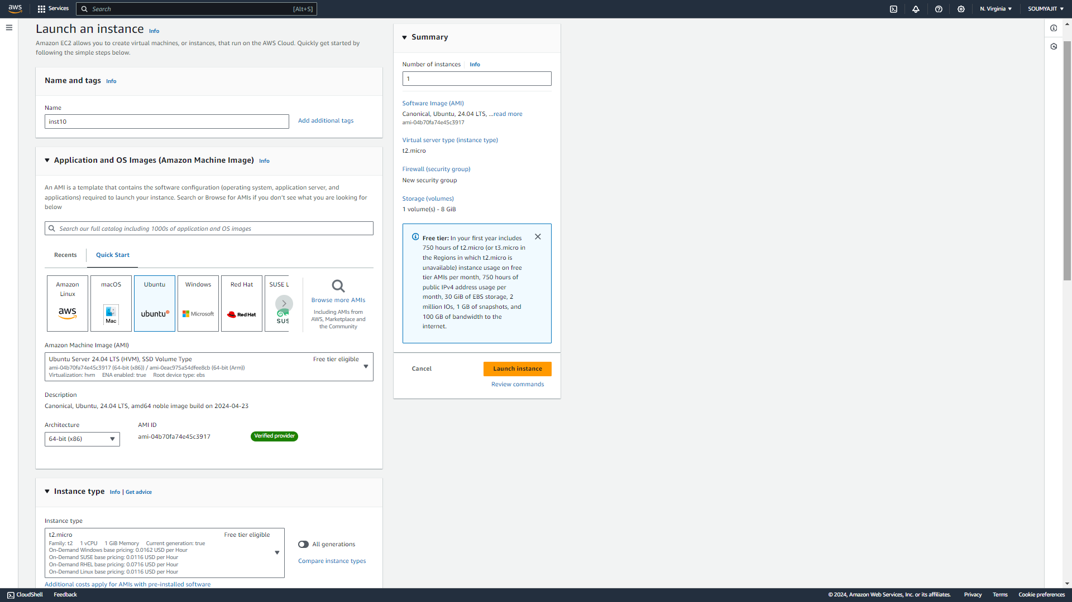

1. Select an existing key pair or create a new one.
2. Now, select “Existing security group” and select the newly created security group.

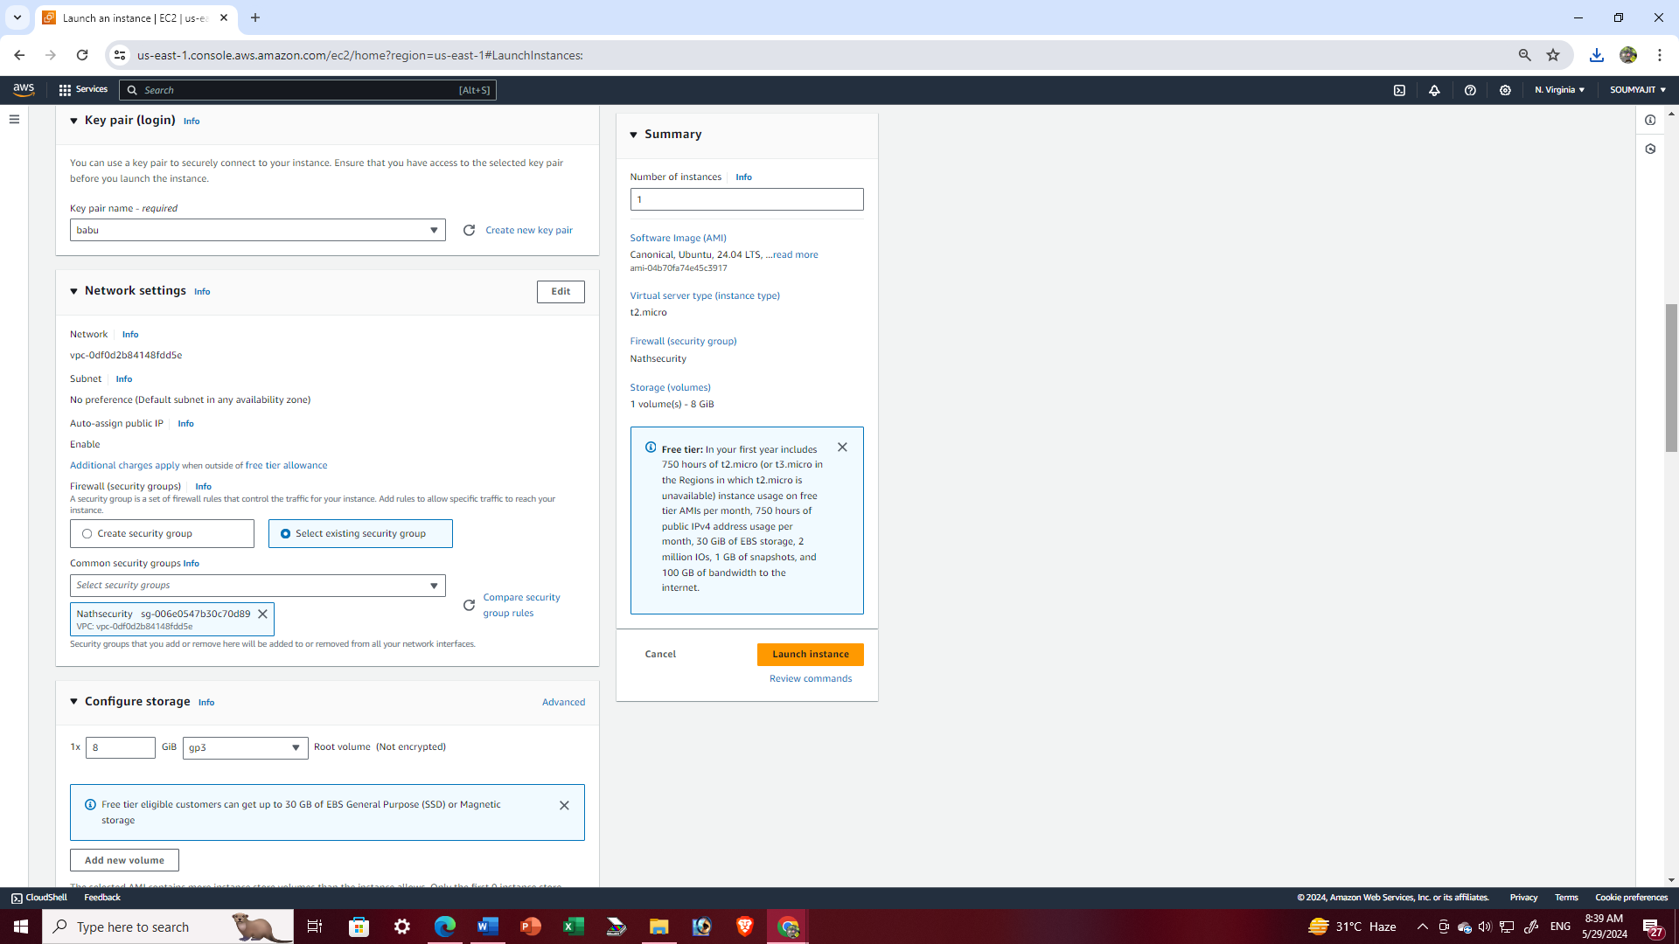

1. Expand the “Advanced details” section. And write this code

#!/bin/bash

apt-get update

apt-get install -y nginx

systemctl start nginx

systemctl enable nginx

apt-get install -y git

curl -SL https://deb.nodesource.com/setup_16.x|sudo -E bash -

apt-get install -y nodejs

git clone http://github.com/sudip7407/Repo1.git

cd Repo1

npm install

node index.jsClick on “Launch instance”.

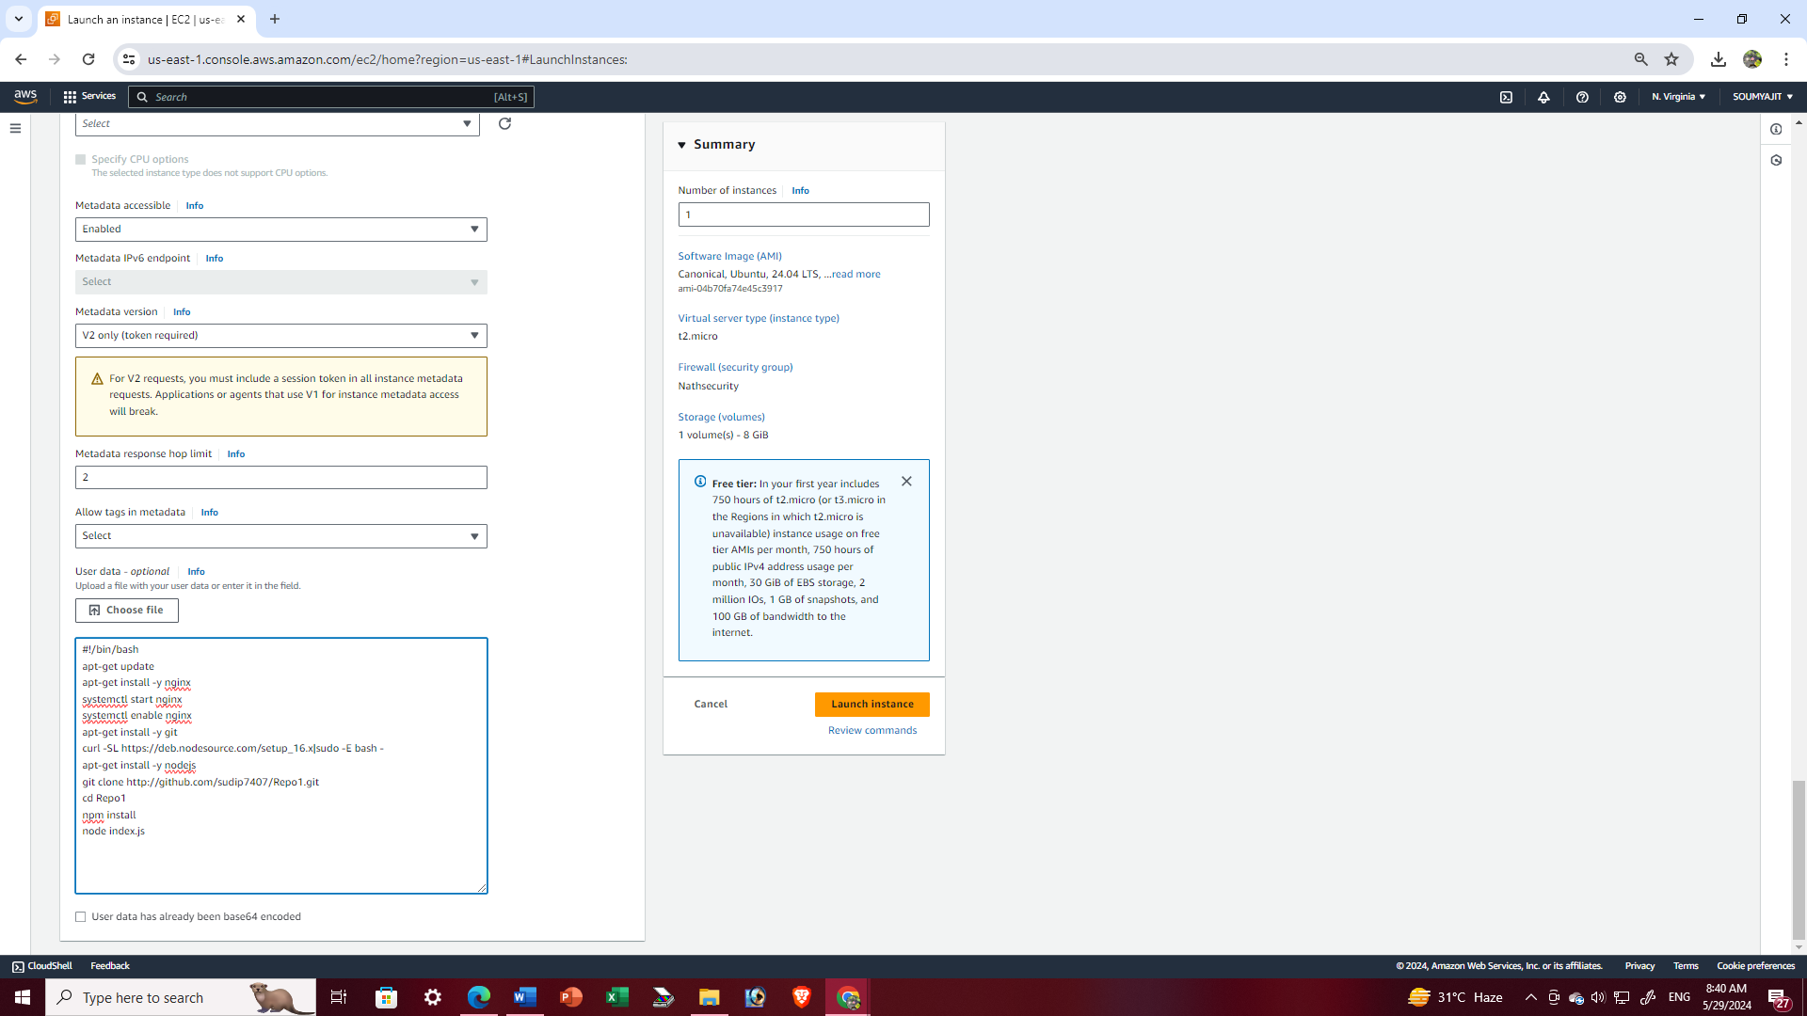

1. Now go to “Instances” and click on the instance id of the newly created instance. Copy the public IPv4 address.

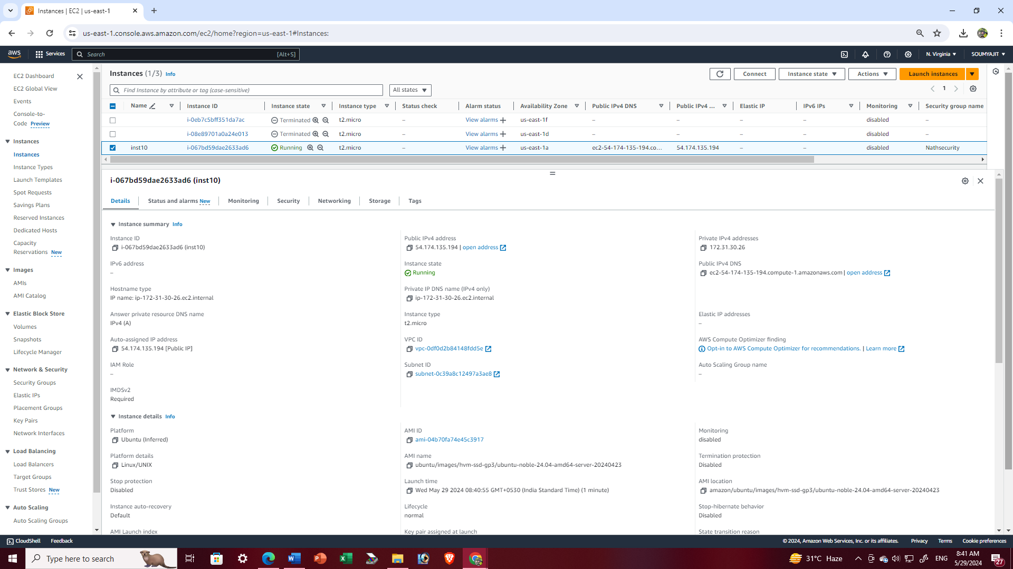

1. Open a new tab and paste the IPv4 address copied and. This will display our intended website.

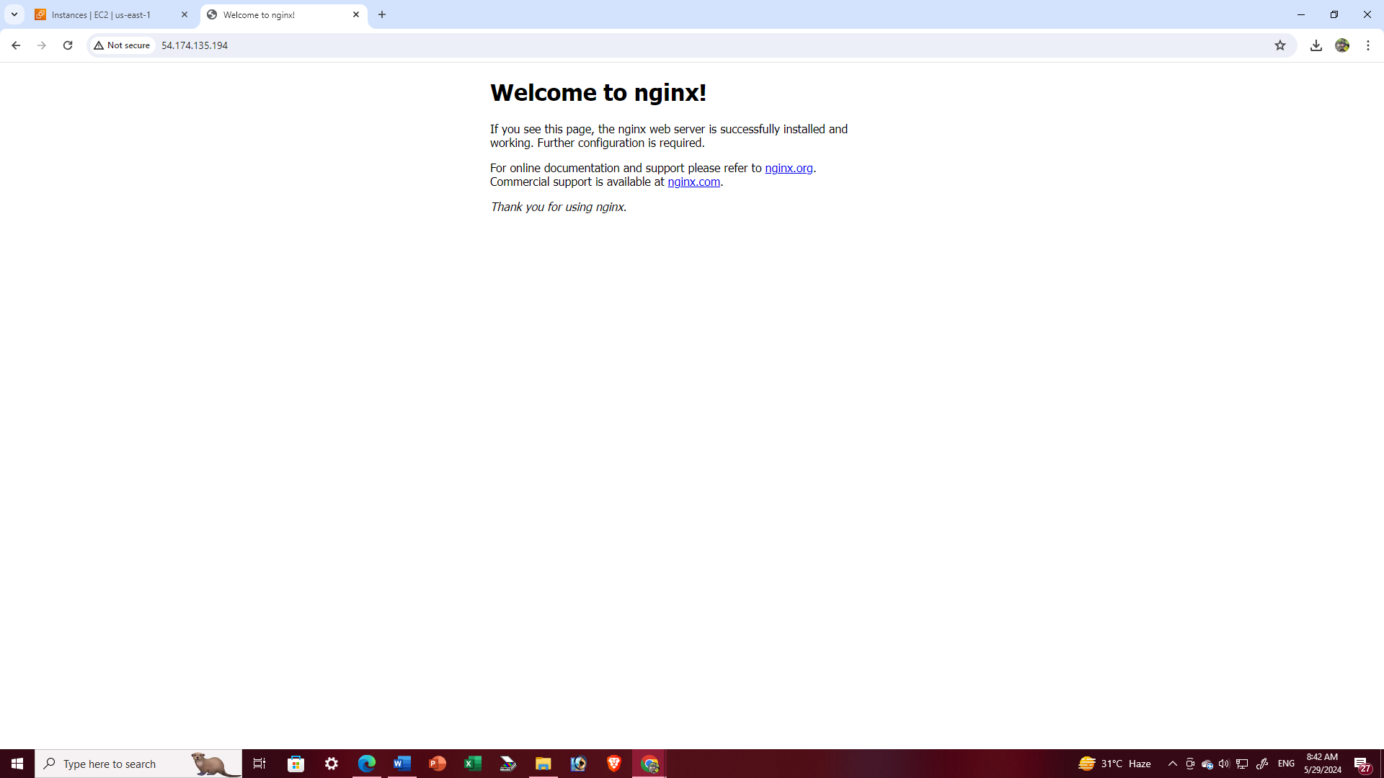

1. Open a new tab and paste the IPv4 address copied and add “:4000” to the end of it. This will display our intended website

